Key Words
Diagnostic Unit “Put your best foot forward”
Page 6
Warm up…. Find someone who….
1. plays soccer. ______________________
2. practices an extreme sport. ______________________
3. likes water sports. _______________________
4. practices boxing. ________________________
5. is in martial arts classes. _______________________
6. runs around the soccer field ten times without stopping. _________________________
7. practices parkour. ________________________
8. practices skateboarding. _________________________

How much do you know…?
Complete the chart with name of famous artists.
Name | Costa Rican | Foreigner
Actor – Actress | Mario Chacón
Athlete
Comedian
Dancer
Journalist
Painter
Sculptor

Now, write 5 sentences with the name of the artist you wrote previously. Use the verbs in the box.
Perform play sing dance sculpt

1. Mario Chacón performs a Costa Rican movie.
2. _____________________________________________________________.
3.________________________________________________________________.
4.________________________________________________________________.
5.________________________________________________________________
Page 7
Write the English name of the electrical appliances you identify.



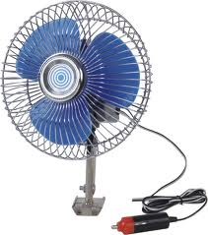
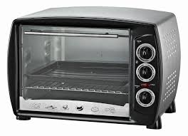

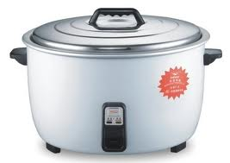

TV (set) blender microwave oven fan rice cooker

How often do you….?
Add the adverb of frequency in the right place:
- I sing while taking a shower. (sometimes)
I sometimes sing while taking a shower.

- She practices team sports. (never)
She never practices team sports.

- We play soccer on Sunday evening. (often)
We often play soccer on Sunday evening.

- He runs ten kilometers everyday in the morning. (always)
He always runs ten kilometers everyday in the morning.

Listen to a conversation about an Australian tourist and receptionist from a Costa Rican hotel. Listen to it as many times as possible to complete the dialogue.

Hotel Clerk: You are calling to Lapas Beach Hotel. May I help you?
Tourist: Sure. I’d like to reserve a double room on July 26th.
Clerk: Ok. I am checking the reservations right now. There is vacancy on July 27th but not on that day. It is all booked.
Tourist: Oh, let me think about it. What about July 25th?
Clerk: Well, we have one room available equipped with kitchen, stove and cable. It is front beach.
Tourist: Great! How much is it?
Clerk: $75 a night.
Tourist: Ok, that’ll be the one.
Clerk: All right. Tell me your full name.
Tourist: Bill Sullivan.
Clerk: See you soon, Mr. Sullivan.
Tourist: Good bye.

Page 8
Below there are some ecological problems that affect our planet. Identify them and underline them. 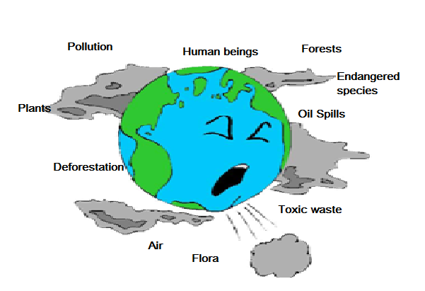

Now from the list below, write the natural resources that are affected by those ecological problems.

Problem | Natural Resources
1.  Pollution | Flora, fauna, water, soil…
2.  Deforestation | Trees, forest, plants, water, animals…
3.  Toxic waste | For a, fauna, water, air….
4.  Endangered species | Animals, plants, trees…
5.  Oil spills | Marine fauna and flora, marine habitat

Page 9 and 10

Diagnostic Exam

Multiple Choice

- B
- A
- C
- B
- A
- B
- C
- B
- A
- A

Page 11
- D
- C
- A
- A
- A
- C
- A

Page 12

A
F J G
E B H
D I C

Guitar – marimba – bongo – drums
Clarinet – violin – guitar – flute

Page 13

Word | Prefix | Suffix | Root
Teacher |  | -er | Teach
Journalism |  | -ism | Journal
Misbehave | Mis- |  | Behave
unhappy | Un- |  | happy
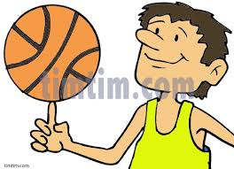
Write sentences using the picture next to each line and the word in parenthesis.
Examples:
- I usually play basketball. (usually)

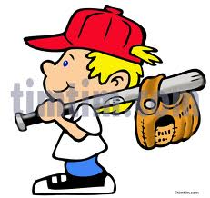
- He always plays baseball. (always)

Page 14
Look at the picture below and answer the information requested. Long answers.
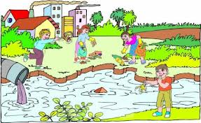

- Which natural resources are in the picture?
Plants and water are the resources in the picture.
- What are the kids doing?
The kids are cleaning the river, forest…..
- Which are some ecological problems pictured in the drawing?
Air pollution and water pollution are some of the ecological problems in the drawing.
- What should you do help nature?
I should clean rivers……
- How trash can be handled?
Trash can be reused, recycled….

Unit 1 “ Don’t think it twice… practice a sport!

Page 17
Roller skating – climbing – bungee jumping – parachuting
Cycling – weight lifting – swimming
Horseback riding – bowling – down hill/ freestyle

Page 19
1. track
2. snow boarding
3. baseball
4. boxing
5. swimming
6. tennis
7. surfing
8. weightlifting
9. soccer
10. bowling
11. ping pong
12. basketball

Write 3 sentences……
Examples:
I like do aerobics
I don't like running
Page 20
rafting - white water rafting

J
H
G
F
C
B
D
E
I
A
Page 21
1. No
2. Yes
3. No
4. No
5. Yes
6. Yes
Now think about 5 different……
white water rafting - kayaking - down hill - rappelling -
bodyboarding- parkour -
free scuba diving - skateboarding -
cliff jumping - bungee jumping - snowboarding - skiing -
free style motocross -
hang gliding - climbing
surfing - grassboarding -
sandboarding...

Page 22
1. D
2.H
3.A
4.G
5.B
6. C
7. E
Page 23
1. plays
2. practices
3. runs
4. swim
5. ski
6. does
7. don't go - do not go
8. doesn't skate - does not skate
9. don't know
10. don't shoot
11. doesn't wake up
12. competes
13. are
14. trains
15. dispute
16. participates
Page 25
C
A
D
B

- C
- C
- A
- C

Air tank refills are needed F
More mobility is allowed T

Page 26
Bryan Ruíz - Laurens Molina - Gabriela Traña
Warner Rojas – Andrey Amador – Leonardo Chacón
Hanna Gabriels – Claudia Poll – Nery Brenes

Page 29
- A
- C
- A
- B
- B

Page 30
E
A
H
C
G
B
I
F
D
Page 31
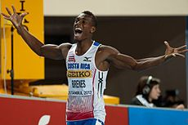
Personal Background
Full name: | Nery Antonio Brenes Cárdenas
Nationality | Costa Rican
Born | September 25, 1985  Limón, Costa Rica
Sport
Sport | Running
Event(s) | Sprints
Achievements and titles
Personal best(s) | 200 m :20.62 (San José, 2012)  400 m: 44.65 (Guadalajara, 2011)
Medals | How many? | One Competition/Event Name
Gold | 13 | Pan American Games
Silver | 1 | Central American Championships
Bronze | 2 | NACAC Championships

Page 33
2
7
3
5
1
6
4

A
D
B
D
D

He was born on december 15th,1986.
He comes from Pérez Zeledón, Costa Rica.
Yes,he has.

Page 34
B
A
A
B

The downhill is an alpine skiing discipline.
Recer on a typical... in certain sections are expected.

Page 35
Gymnastics – basketball – soccer – hockey – running
Baseball – karate – tai boxing – golf – bowling
Frisbee – swimming – tennis - cycling – snow skiing –
Skateboarding – boxing – scuba diving – volleyball – chess

Page 36
- Baseball
- Boxing
- Golf
- Cycling
- Hockey
- Soccer
- Bowling
- Swimming
- Surfing
- Diving
- Skiing
- Tennis
- Sailing
- Volleyball

Page 37

A
B
A
A

Page 38

D
B
C
C
A
B

Unit 7 “I feel it in my bones!”

Page 164
Sore throat – fever – headache – toothache – (chicken pox – allergy – rash)- sunburn

- Chamomile tea….
- Lotion…
- Chicken soup ….
- Nasal spray….
- To be casted …

D I L
F A J
C H K
G E B

Page 165
B
A
C
A
B
C
D
Page 165
- She has a toothache /Hertooth aches hurts
- I have a sunburn
- He has diarrhea
- They are getting the flue

- She must go to the dentist
- I should take an aspirin
- She ought to drink some syrup
- She had better take some antibiotics
Page 167

Carlos problem: Carlos is having a nervous crisis...

Page 169
C
C
D
D

Illustrations
5 - 4 – 2/3 – 1

- F
- T
- T
- T
- F
Page 170
Script: Listening Activity: At the doctor’s office

Listen to a patient talking to a doctor about her health complaints. Listen to the conversation as many times as necessary to complete the patient information form below.

Doctor: Good morning Mrs. Campos. What’s the matter with you?
Patient: Hello Mr. Rojas. I don’t feel well. I have a terrible headache, fever, sore throat and all my body aches.
Doctor: Do you have rash on your body?
Patient: A little bit.
Doctor: Ok. You must take a blood test immediately.

1 hour later

Doctor: Based on the blood test results you got dengue. You must drink plenty of liquid and get some rest. Take one acetaminophen 4 times a day in case you have fever or any kind of sore.
Patient: Is dengue a contagious disease?
Doctor: Yes, it can be transmitted by an insect bite, so ask your relatives and the people who surround you to use repellent day and night.
Patient: What should I use for my rash?
Doctor: Use this crème twice a day until it disappears. Don’t forget to take a blood test everyday during a week.
Patient: Thank you doctor.
Doctor: You’re welcome. Today is October 16th. Call me in three days to know about your health.

Page 171
Across
2. cast
5. broken
6. lozenge
7. chills

Down
1. vitamins
3. sun lotion
4. disease
5. bruise

Page 173
1. B
2. C
3. B
4. B

Page 174
1. D
2. A
3. B
4. C

Page 175
After Reading: C (invite)
Scanning:
- Volunteer doctors
- The public
- Central Park in San José
- Heart disease facts and prevention
- Tests

Page 177
1. A
2.C
3. D
4. C
5. B
6. B
7. C
8. C

Page 178
Causes
1. having sex
2. sharing needles
3. being born from an infected mother
4. having a blood transfusion of infected people
Symptoms
1. fever
2. night sweats
3. diarrhea
4. swollen lymph nodes
Consequences
1. pulmonary infections.
2. gastrointestinal infections
3. syphilis
4. cancer
5. pneumonia

- In 1967.
- Expossure to infected tissues in monkeys and other primates.
- Central Africa.
- From 5 to 10 days.
- In Yugoslavia and Germany.

Unit 8 “It’s time to celebrate”

Page 182
José María Castro Madriz - José Figuérez Ferrer – Rafael Angel Calderón Guardia

B
C
B

Page 183
B
C
B
C
C
A

Page 186

Social Security Monument – Flag Mon. – National Mon.- Juan Santamaría Mon

1. The Social Security Monument
2. Labor, freedom, equality........
3. In 1993
4. In San José, Zapote.
5. Rafael Angel Calderón Guardía
6. Eight

Page 187
Script: Listening Activity

Prize for Costa Rica
Óscar Arias Sánchez was born in September 13, 1940 in Heredia, Costa Rica. He was President of Costa Rica from 1986 to 1990 and from 2006 to 2010. In the first presidency, he received the Nobel Peace Prize in 1987 for his efforts to end the Central American crisis.
The president Arias received the Nobel Peace Prize with the help of John Biehl, his peer in England, and Rodrigo Madrigal Nieto for his work towards the signing of the Esquipulas II Accords. This was a plan intended to promote democracy and peace on the Central American isthmus during a time of great turmoil: leftist guerrillas were fighting against the governments in El Salvador and Guatemala, which were backed by the United States under the auspices of the Cold War; the Contras, supported by the United States, were fighting an insurgency against the Sandinista government in Nicaragua; Honduras, only recently wresting political power from its military, was caught in the middle as a base for U.S. military forces; and on Costa Rica's other border, Panama faced the oppression of Manuel Noriega's military dictatorship. With the support of Arias, the various armed conflicts ended within the decade. Guatemala's civil war finally ended in 1996.
Taken from Wikipedia, the free encyclopedia http://en.wikipedia.org/wiki/%C3%93scar_Arias

1. The Social Security Monument
2. Labor, freedom, equality........
3. In 1993
4. In San José, Zapote.
5. Rafael Angel Calderón Guardía
6. Eight

Page 188
1. Dictatorship
2. Anarchy
3. Democracy
4. Monarchy
5. Socialism
Page 189
1. A
2. S
3. A
4. S
5. S

Interesting Information…
-The torch of independence
- The flag
-The white tailed deer
- The Guanacaste Tree
- The typical oxcart
-The purple orchid
-The marimba

Democratic values represented by the national symbols: Life, peace, labour, liberty, respect, justice......
Page 191
1. A
2. C
3. D
4. C
5. C
6. B
Page 193
1. C
2. A
3. A
Page 194
Democracy:
1. Leaders are elected popularly.
2. The constitution guarantees basic human rights, fair and free elections.
3. Independent courst of law.
4. Separation of Powers
5. Freedom of opinion, speech.....
Totalitarian Regime:
1. It is government by a little group of leaders.
2. It attempts to replace religion.
3. It is not tolerant.
4. Opponents are detained and tortured.
5. Opponents are bound to leave the country.

The National Coat of Arms
1. Merchants sailing on each of the two oceans.
2. By seven stars
3. The number of stars
4. Above the strip of ribbon that says "República de CR".
5. "Ámerica Central"
Page 197
Post-Reading
1. C
2. C
3. D
4. B

Based on the reading…..
1. B
2. A
3. A
4. C

Page 198
1. C
2. A
3. A
4.C
Page 199
1. D
2. A
3. D
4. B
1. MONARCHY
2. DEMOCRACY
3. DICTATORSHIP
4. ANARCHY
Costa Rica National Symbols:
1. The National Coat of Arms
2. The National flag
3. The oxcart
4. The purple orchid
5. The white tailed deer
6. The National Anthem
Page 200
T N E D I S E R P O G E Q N B
K Q F Z S L U P E J I L T R B
V F R M O N A R C H Y M D O R
E L E C T I O N T E W A E I V
X J A N A R C H Y S E W M J K
T O L L A B E W R V Z P O O J
P I H S R O T A T C I D C D U
Z Z U U O E C H Z C D G R B C
Y X Z T T M M Q X C B J A W H
N Y K Z X Y I E V V Z Z C U C
I N G H W W R Z R M H S Y H O
N M O U E H Y I R P S H S L U
Z C M Q E Q A Y S S U V P O R
M A G I S T R A T E S S Y F T
Q F A Z I H O Q D C S O M U M

Page 201
1. C
2. C
3. D
4. A
5. C

Page 202
6. B
7. A
8. C
9. B
10. B
11.D

