Unit 2

I LOVE ARTS AND MUSIC OF COSTA RICA

Warm-up (página 42)

Can you guess the instruments? Match the words with their corresponding picture. Write them in the spaces.

QUIJONGO CONGA BANJO

Practice (página 46)
Based on the following simple present affirmative sentences, write simple present questions.

- We are artists and dancers.
Are we artists and dancers?
- They like roots rhythm.
Do they like roots rhythm?
- The Jade Museum opens every day.
Does the Jade Museum open every day?
- I want to make handicrafts.
Do you want to make handicrafts? / Do I want to make handicrafts?
- Francisco Amighetti was a famous Costa Rican painter.
Was Francisco Amighetti a famous Costa Rican painter?
- Mario and Juan play salsa with the band.
Do Mario and Juan play salsa with the band?
- She paints landscapes in watercolours.
Does she paint landscapes in watercolours?
- Isidro Cong Wong is an artist, painter, and Costa Rican sculptor.
Is Isidro Cong Wong an artist, painter, and Costa Rican sculptor?

PAGINA 47

2. Write the missing auxiliary and words of the following questions.

- Does she dance reggae? Yes, she does
- You like Costa Rica rhythms? Yes, I do.
- How much does it cost to get to the national theatre?
- I have question: do they know how play calypso?
- Excuse me, do you make handicrafts?
- Do I have to paint the landscape again?
- I want to study arts, do you know an institute of arts?
- What arts does he like the most?

3. Based on the following simple present affirmative questions, write yes / no answers.

- Do they know where to show their handicrafts? Yes, they do. / No, they don’t.
- Do we play salsa? Yes, we do. / No, we don’t.
- Does Monserrat sing with us? Yes, she does. / No, she doesn’t.
- Is he a painter? Yes, he is / No, he isn’t.
- Are you a musician? Yes, I am / No, I am not.
- Do I paint in watercolours? Yes, I am / No, I am not. / Yes you do. / No, you don’t.
- Do you know a museum to visit? Yes, I do. / No, I don’t.
- Doe he play the congas? Yes, he does. / No, he doesn’t.

4. Organize the following words in order to write simple present questions?
- (she / play / the bongo) Does she play the bongo?
- (paint / they / in watercolours) Do they paint in watercolours?
- (exhibit / our arts / we / today) Do we exhibit our arts today?

5. complete the following questions. Use the appropriate auxiliary and the verb in parenthesis.

- Does she dance?
- What time does the concert start?
- Where do they buy the tickets for the play?
- Are you a painter?
- Where does he play the electrical guitar?
- Do I paint landscapes?
- Where does she make her art works?
- Is she a dancer?

PRE-READING (página 48)

- False
- True
- False
- False
- True
- True
- True
- True
- False
- False

POST-READING (página 49)
Complete the following chart from the previous tex

- Province where people can buy the Chorotega handicrafts.
Guanacaste
- The three places where people can buy the handicrafts in Guanacaste
Guatil
Santa Cruz
San Vicente
- Profession in charge of studying the indigenous pottery.
Archeology
- Three materials artisans use to make the handicrafts.
Mud
Iguana
Black, red and white stones
- Name the handicrafts artisans make.
Vessels
Ocarinas
Vases
Turtles
Jaguars

PRE-READING.
Take a look at these pictures. Now, circle the words you can relate with these pictures.

Acting actresses architect Dancers doctors

Folkloric dancing Nurses Parades Play Politicians

POST-READING
- How many shows does the text mention?
C) Nine

- The Artistic Group performs at
- Pueblo Antiguo Theatre

- The Pasacalles Circense is a
- Circus parade

- Women’s dresses are made of
- Charmelaine

- When does the Artistic Group perform?
D) On weekends

- When did the Artistic Group start? It started
D) in 1995

- How many parade shows do they perform?
- Two

- The plays they act mostly talk about
- Legends and peasant family stories

- What’s the show people can participate in?
- El carretón de la fantasia

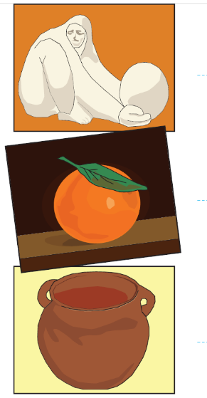
SCULPTURE

PAINTING

POTTERY

- Jade Museum reopens in new location TRUE
- The new building is located in Plaza de la Democracia TRUE
- President Luis Guillermo Solís gave a speech FALSE
- The Museum’s full collection includes 8,000 individual pieces of jade FALSE
- Jade Museum opened in October, 1977 TRUE
- According to the staff, the museum received 30,000 visitors in 2013 TRUE
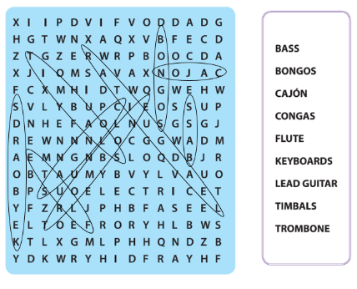

CANTOAMÉRICA

- What does Manuel Monestel play?
The guitar

- How many records does Cantoamérica have?
Fourteen records

- Who were the first members of the band?
Rodrigo Salas, Carlos Saavedra, Roberto Huertas and Bernal Monestel

- Which artists has Cantoamérica performed with?
The have performed with Editus, Mercedes Sosa Pablo Milanés and Silvio Rodríguez

- Who plays flute in Cantoamérica?
Abigail Huertas

- Who writes the songs of Cantoamérica?
Manuel Monestel

- What are the five countries they have toured in the American continent?
Guatemala, Benin, Taiwan, Colombia and USA.

GAVIOTA

- Gaviota was founded in 1977

- Armando Manzanero produced the album Mil Besos

- “Ana mía” was a hit from 1983

- The last record includes the song Acércate

- Acércate was the official song form Mundial de los Pirineos Festival

NATIONAL SYMPHONY ORCHESTRA

- How many musicians are members of the National Symphony Orchestra?

Six albums

- In what year did the National Symphony Orchestra visit the whole country?
In 2015
- When was the National Symphony Orchestra nominated for the Latin Grammy Awards?
In September 2013
- Jiménez Deredia studied in
Florencia, Italy
- In Florencia, Jiménez Deredia studied
Sculpture
- The sculpture of ___________is located in Costa Rica.
Juan Pablo II

EXTRACLASS WORK

- How old are you?
- What’s your favorite hobby?
- What’s your favorite food?
- What will you do next year?
- What do you think about your achievements until now?
- Do you like to eat a lot of deserts?
- Do you like to travel around the world?
- Do you prefer to stay at home or go to a party on weekends?
- Do you have a favorite singer?
- Do you have a dog?

Unit 3

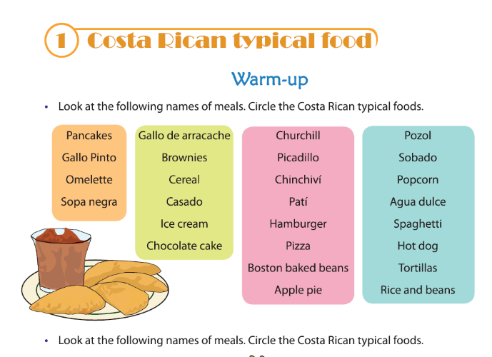

Do you know other Costa Rican dishes or recipes? Write them in the spaces below.

- Picadillo de zorrillo
- Sopa de mondongo
- Plantintá (limonense)

- In the previous listing you can find the meal times; arrange them in the space below and write some foods per each meal time.

MEAL  TIME | BREAKFAST | LUNCH | DINNER
FOODS | GALLO PINTO  AGUA DULCE | SOPA NEGRA  CASADO  PATI  POZOL  RICE AND BEANS | SOPA NEGRA  CASADO  PATI  POZOL  RICE AND BEANS

PRACTICE
Imagine that you are helping your mother prepare a birthday party. Using the vocabulary studied write five foods that you need for the party.

MAING COURSE | SALDAD | DESSERTS
SOPA NEGRA | LETTUCE WITH CUCUMBER | CHURCHILL

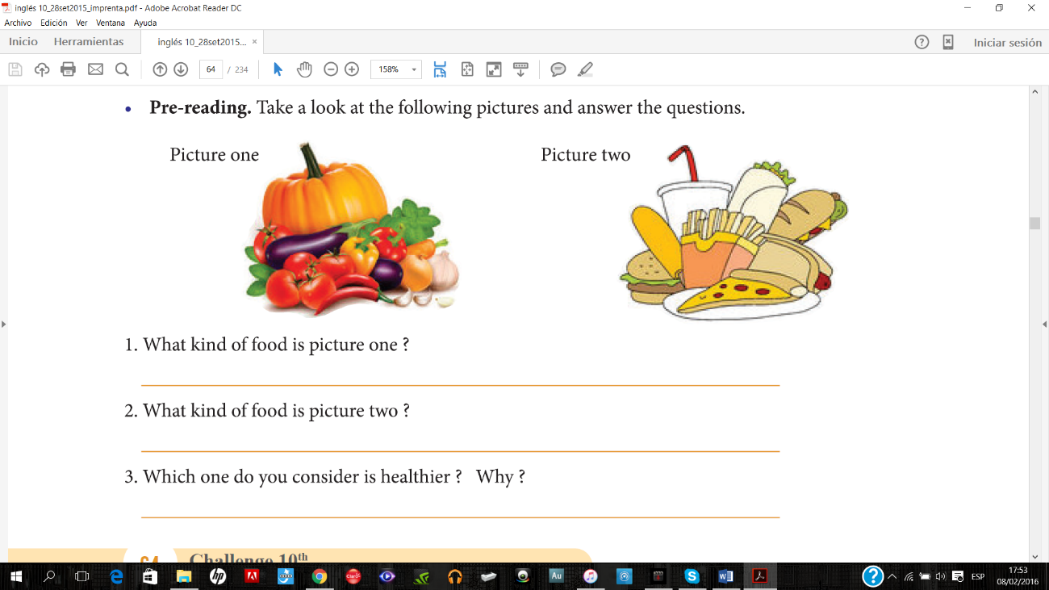

Healthy food
Junk food

Picture one because it is natural there is no artificial ingredients.

POST-READING. CHOOSE THE APPROPRIATE ALTERNATIVE

- According to the text
Ticos have realized they must eat healthy food.
- What is a pesticide?
It’s just another fertilizer

- Where can Ticos find healthy foods? In
Feria Treque

- A synonym of the word obese is
Fat

- Oral communication practice. Complete the sentences with the words in the circle. Then, practice with you partners the dialogue about teenager’s favorite food.

- Do you cook your food?
- I love to drink orchata.
- I eat picadillo de arracache; it’s my favorite dish.
- My mother taught me to mince the chayote.
- Mmm…something tells me that you love to chew bubble gum.

FOCUS ON GRAMMAR.

- What are the most popular dishes in your community?
The most popular dishes in my community are soup, beans and rice.

- What do you eat for breakfast? What does she eat for breakfast?
I eat cereal. / She eats gallo pinto.
- What do they eat for lunch? What does he eat for lunch?
They eat sopa negra and picadillo de chayote. / She eats sopa negra.

- Which dish do you like? / Which dish does she like?
I like casado. / She likes casado

- When do you eat fruits? When does he eat fruits?
I eat fruits in the morning / He eats fruits in the afternoon.

- How do we cook the steak? / How do they cook the chicken?
We cook the steak with oil and species. / They cook the chicken with oil and species.

- What kind of food do you like? / What kind of drinks do you like?
I like healthy food. / I like natural beverages.

PRACTICE
Classify the following list of food as countable nouns and mass nouns.

COUNTABLE NOUNS
- Apple
- Apricot
- Chicken
- Grape
- Kiwi
- Lemonade
- Lime
- Mango
- Orange
- Papaya
- Pasta
- Peach
- Pineapple
- Plum
- Strawberry
- Tangerine
MASS NOUNS

- Cheese
- Cake
- Coffee
- Fluor
- Honey
- Juice
- Meat
- Milk
- Oil
- Sauce
- Tea
- Water
- Wine

PRACTICE

With a partner, write a short dialogue using the previous expressions. Then, share it with the rest of the class.

WAITER: Are you ready to order?

ROSE: Yes, I want sopa negra with salad.

WAITER: Can I start you off with a drink?

ROSE: Yes, I want to drink orchata.

WAITER: Right away, ma’am.

ROSE: Can it get this to-go?

WAITER: Sure!

ROSE: Can I get the bill, please?

- Fill in the blanks with the missing words and information in the dialogue. Use the vocabulary of food and the words MANY, FEW, A FEW, SOME, TOO MANY, A LOT OF, ANY, TOO MUCH, AITTLE, and HOW MUCH. You can repeat the words, if necessary.

ALF: Yes! I am hungry, too. I ate a little bread.
MARRION: I didn’t have time to have breakfast, so I drank some coffee.
ALF: My mother and I ate some mash potatoes with orange juice.
MARRION: I am used to eating an apple and a tangerine.
ALF: Really? Well, let’s go! I heard there is a typical restaurant downtown.
MARRION: Great! I don’t want to eat a lot of steak. I am eager to eat some chicharrones.
ALF: By the way, how many hard-boiled eggs did you eat last Saturday?
MARRION: Hey don’t be mean with me! I was starving.

At the restaurant

Marrion: Have you got some strawberries in the house?
Waitress: Actually we have a few fresh strawberries with condense milk.
Alf: That is too much food. Anyway, I want to order Pan Bon and a Rice and Beans.

PRE-READING. Take a look at the following pictures. Write the name of each one in the spaces below.

- Fried plantains
- Scrambled eggs
- Sour cream
- Rice and beans

POST-READING
- “Gallo Pinto” means rice and beans mixed.
- What sauce do Costa Ricans like to pour in the Gallo Pinto?
Lizano
- Gallo Pinto is a typical breakfast meal.
- This recipe came from Africa.
- Two ingredients used in Gallo Pinto are coriander and clove.
- People like to eat Gallo Pinto with scrambled and sunny side up eggs.
- People drink coffee with Gallo Pinto.

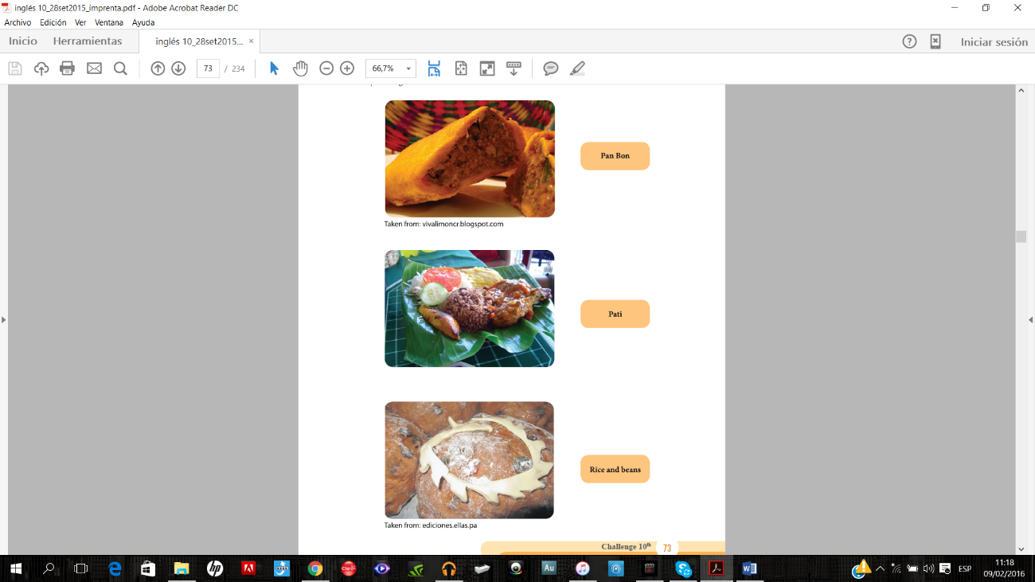
PRE-LISTENING. Look at the following pictures. Match the picture with the corresponding name by drawing a line.

WHILE-LISTENING

Emma and Harry are doing their homework about Limón cuisine. Try to guess what goes in the blanks. Listen to them and check twice.

HARRY: Would you like something to drink before we start to do the homework, Emma?

EMMA: Yes, just some water, please.

HARRY: Sure!

EMMA: Thank you, Harry. By the way, did you find the information about Limón cuisine?

EMMA: Yes, I did. Nevertheless, I think it’s not enough. We need to find out more about it.

HARRY: To be honest, I found one recipe, but I guess we need to discuss a little bit.

EMMA: Let’s see, according to the readings I have, Limón is a melting pot of traditions and culture.

HARRY: What are the most popular dishes in Limón?

EMMA: Well, there are many. Some of the most popular dishes in Limón are Pan Bon, Pati and Rice and Beans.

HARRY: Slow down, Emma. What is Pan Bon?

EMMA: It’s a sweet bread made with spices. In order to bake it, it needs flour, yeast, oil, vanilla, cinnamon, candied fruits, raisins and water.

HARRY: It sounds delicious! What about Pati?

EMMA: If you see the Pati, you might think it is a turn over. Although, teacher says we have to say “empanada” because typical food doesn’t have translation. Nonetheless, you might explain it by using English vocabulary of food, if necessary. Anyway, the ingredients are very simple: flour, lard, ground beef, and hot pepper.

HARRY: I have never heard it before. And the last one? Is it Gallo Pinto?

EMMA: Not exactly, both of them have the same grains, but the flavor is completely different. You need to take rice, beans, coconut, and thyme. Although, this dish has variations. For instance, some people like to add chicken and salad.

HARRY: I am starving. Listen what I found: the Rondon.

EMMA: It sounds interesting. Go ahead!

HARRY: It’s a fish soup. Basically, in order to cook Rondon, you need to have coconut milk, plantain, vegetables, spices and Panamanian chili pepper.

EMMA: All these recipes came from African roots. Due to the railroad construction in 1890s, immigrants came from the Caribbean islands to build it. Afterwards, they worked in the banana plantations. Immigrants came from Jamaica, as well.

HARRY: Which dish do like from Limón?

EMMA: Definitely Rice and Beans. And yours?

HARRY: I don’t know, yet. Let’s go to the restaurant!

EMMA: Great idea!

Information to find in the dialogue | Your answers
Recipes from Limón | Pan Bon, Pati, Rice and Beans and Rondon
Ingredients of Pan Bon | flour, yeast, oil, vanilla, cinnamon, candied fruits, raisins and water.

- Rondon is a delicious Caribbean soup.
- The pait is “empanada” filled with ground beef.
- The most famous bread of the province of Limon is named Pan Bon.
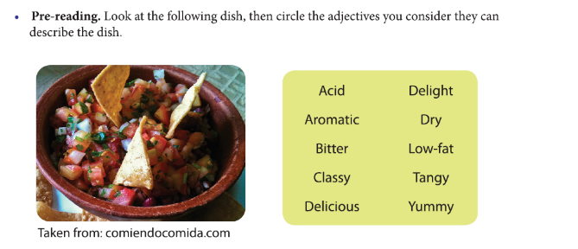
- Coconut milk is one of the basic ingredients to cook rice and beans.

POST-READING. Based on the previous text, answer the following questions.

- What events do Costa Ricans usually prepare the Chifrijo?
Parties, dinners, school parties, family parties and lunch

- What are the ingredients of the Chifrijo?
Pork rind, read beans, rice, tortilla chips, chopped tomato, fresh salsa and “pico de gallo,” slices of avocado, iceberg lettuce, cabbage, sour ream and parsley.

- How much does the Chifrijo cost?
One and a half dollars

COSTA RICA’S BOCAS

- Bocas are small dishes of Costa Rican food.
- According to the text, in Costa Rica there are five varieties of ceviche.
- Crispy, fried corn tortillas are used to prepare chalupas.
- Usually, the gallos have a topping of cabbage salad.
- Tacos are prepared with fried tortillas completely rolled.

- Based on the vocabulary of food, questions and expressions learned previously, create a dialogue with the characters below.

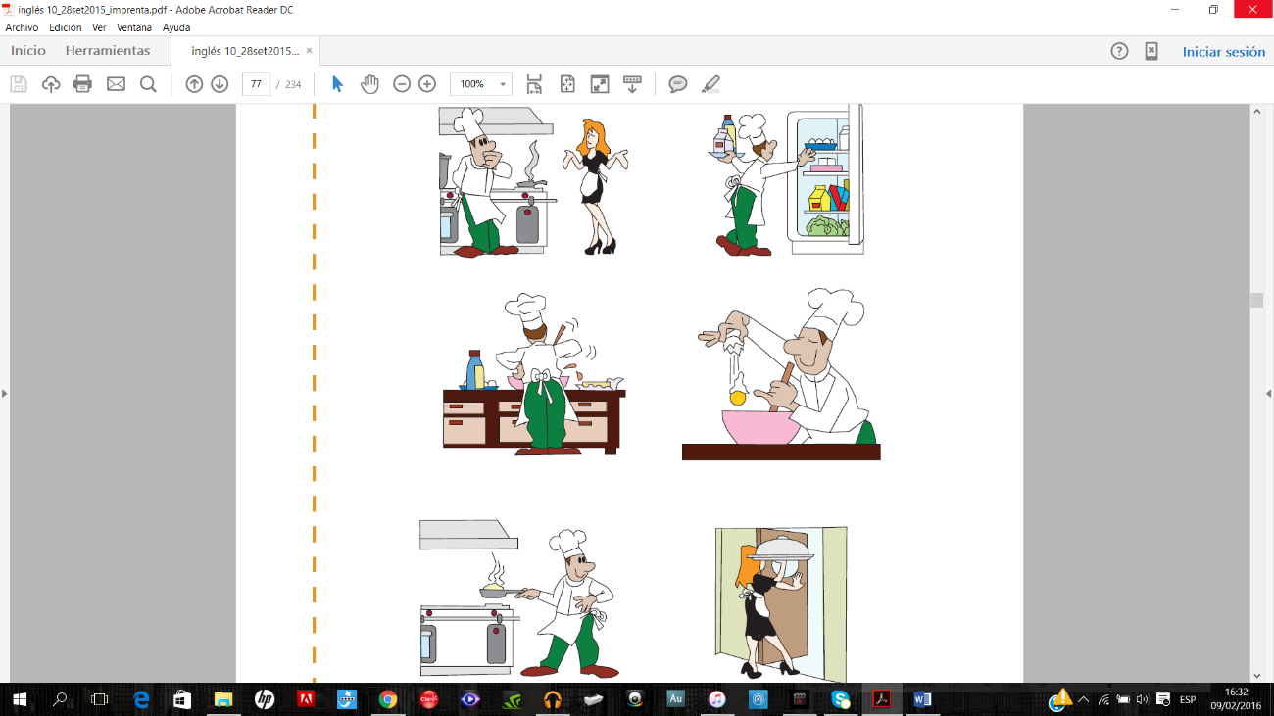

- Aren’t you forgetting something?
- Yes, I need some milk, eggs and
Wine.
- I need a little water for this recipe.
- There is no doubt I am the best chef
In the world.
- Well, don’t forget the today’s special
Because we have a lot of diners.

Some traditional dishes of Costa Rica

- Usually rice and chicken is served with mashed beans.
- Casado is a typical dish for breakfast.
- Chimichurri is prepared with chopped tomatoes.
- Traditionally Costa Ricans serve rice with chicken in the family parties.
- With chopped chayote, corn and ground beef, Costa Ricans can prepare a delicious picadillo.
- Two basic ingredients of Costa Rican food are rice and beans.

SOPA NEGRA

- What is a Sopa Negra? It is a black beans soup.
- How many eggs do you need to prepare a sopa negra? 2 hard-boiled eggs.
- How much time is needed to prepare a black soup? 30 minutes
- The first step to cook the soup is to cook the beans juice.
- When do you have to add the boiled eggs? When the beans are cooked.
- While cooking the soup, be careful of covering and setting for 10-15 minutes.

COSTA RICAN DRINKS

MILK BEVERAGES
- Agua dulce
- Horchata
- Resbaladera
WATER BEVERAGES
- Fruit drink
- Lemonade

- Tamarind

TAMALES

- When do Ticos prepare tamales? On Christmas
- How many ingredients do you need to make tamales? 13
- What is an occasional ingredient used to make tamales? Plum
- What drink is served with the tamal? Coffee
- Where can you eat tamales at any time of year? Restaurants

HOLY WEEK TRADITIONAL FOODS

- In Easter, Ticos prepare many special dishes because they don’t eat red meat.
- The dulce the tapa is used to prepare two dishes during Holy Week.
- The biscocho is bread rolls prepared with corn.
- Non-perishable food means that the food is durable.
- To enrich the taste of codfish soup, many people add coconut milk.
- Besides sweets, breads and seafood, Ticos usually cook picadillos during Holly Week.

Unit 4

IT’S TIME TO CELEBRATE!
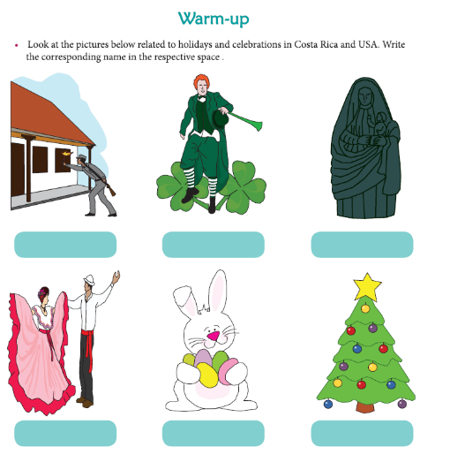

Juan Santamaría Day Saint George Day Virgen de los Angeles Day

Annexation of Guanacaste Easter week Christmas

PRE-READING. Look at the following pictures and write three sentences about them.

Picture one

- It is a carnival.
- She is wearing a costume.
- She is happy.

Picture two
- It is a concert.
- There is a musical band.
- The public enjoys the music.

Picture three
- It is a character.
- The man has make-up.
- He is acting.

CARNIVAL AND CELEBRATIONS IN COSTA RICA

- When do people celebrate Puntarenas Carnival?
February

- Bullfighting is taken place in
Palmares Parties

- Alfred King was the man who brought the first carnival in Limón.

- Who organizes Palmares parties?
Asociación Cívia Palmareña

- Theatre is one activity that people see in Puntarenas carnival.

- Musicians of “comparsas” play with percussion instruments.

- A linking word from the previous text is moreover.

SAINT GEORGE’S DAY IN ENGLAND

POST-READING. Choose the appropriate alternative.

- St. George is the patron of England.
- St. George is celebrated on April 23rd.
- According to the text
St. George killed a dragon.
- On April 23rd, people have to work, it’s not a holiday.
- St. George was born in Cappadocia
- St. George became a/an soldier.
- What happens in spring in the city of Manchester?
Handicrafts and ethnic jewelry are sold.

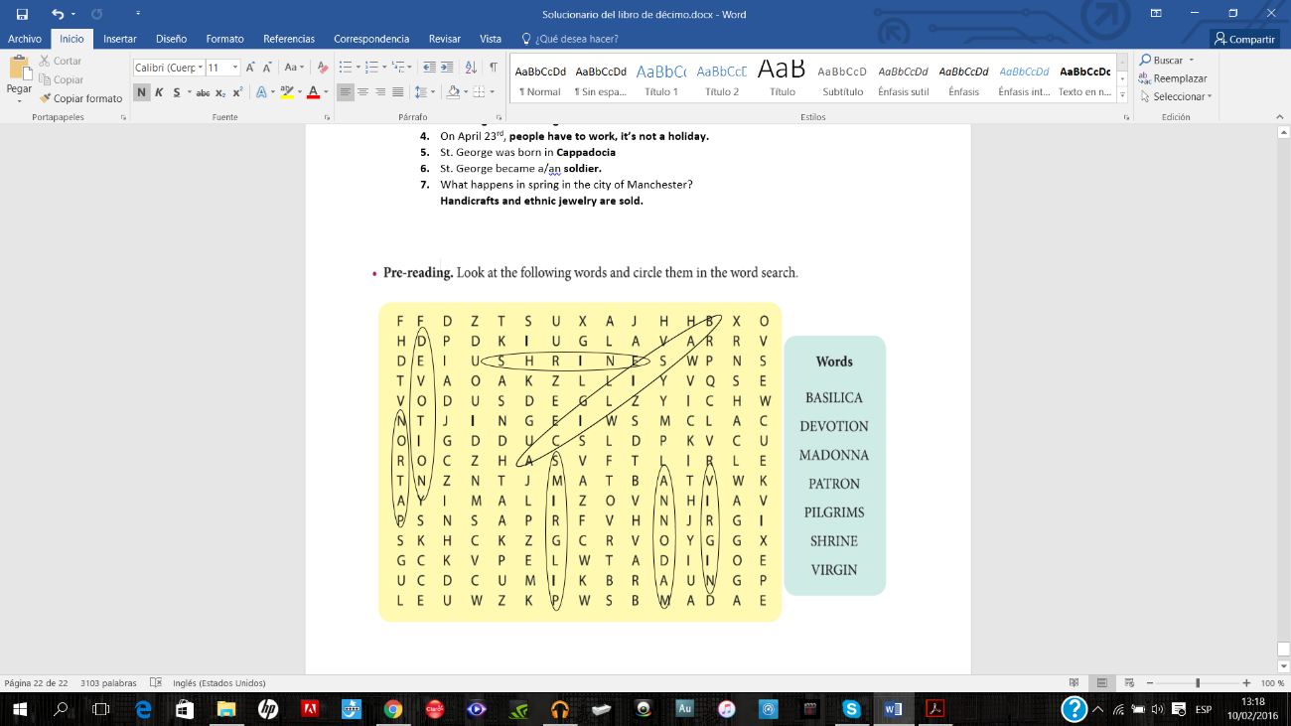

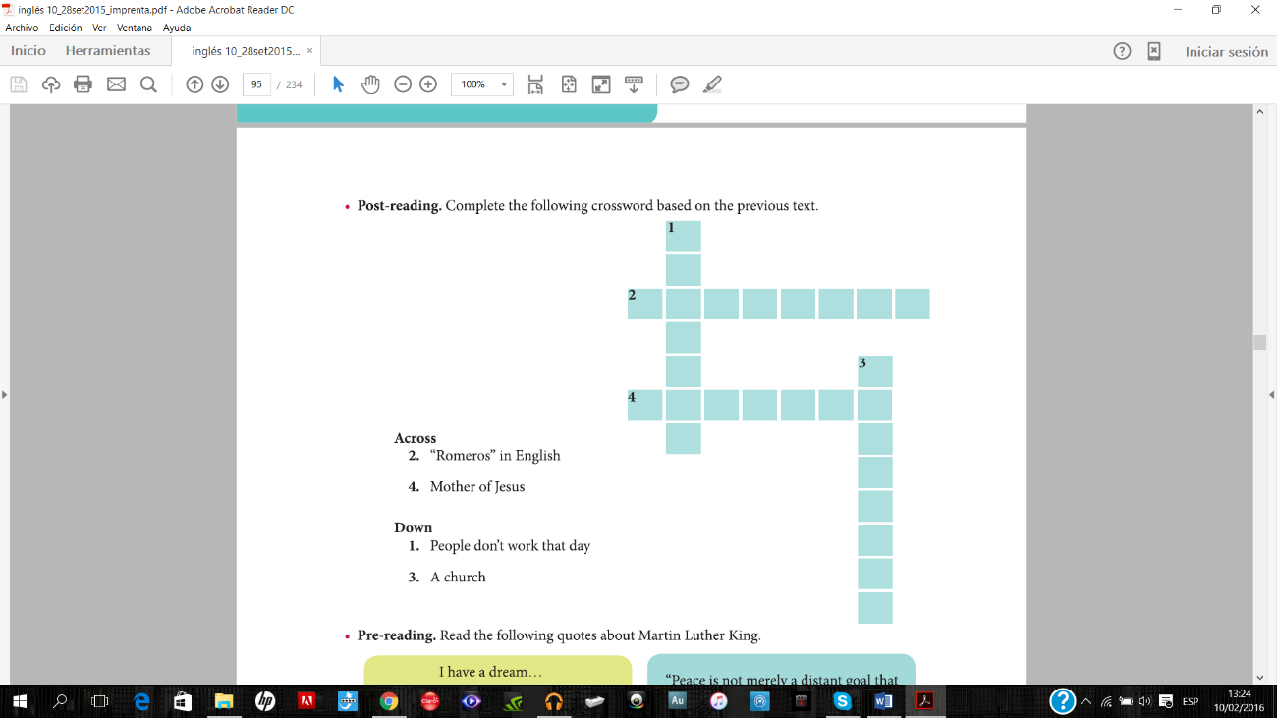
H O

i D

Y

B

S I L I C
A
P I L G R I M S

M A D O N N A

PRE-READING.

Write the quote you like the most
- I have a dream

- Dream
- Goal
- Peace
- Moving forward
- Seek

POST-READING. Complete the following crossword based on the previous text.

INFORMATION OF THE READING | YOUR ANSWERS
Nationality of Martin Luther King | AMERICAN
Date of this official federal holiday | Every third Monday of January
Date when he won the Nobel Peace Prize | December 10th, 1964
Reasons of why people celebrate the holiday | - Value of compassion  - courage  - dignity  - justice  - humility
Date of his assassination | 1968 in Memphis

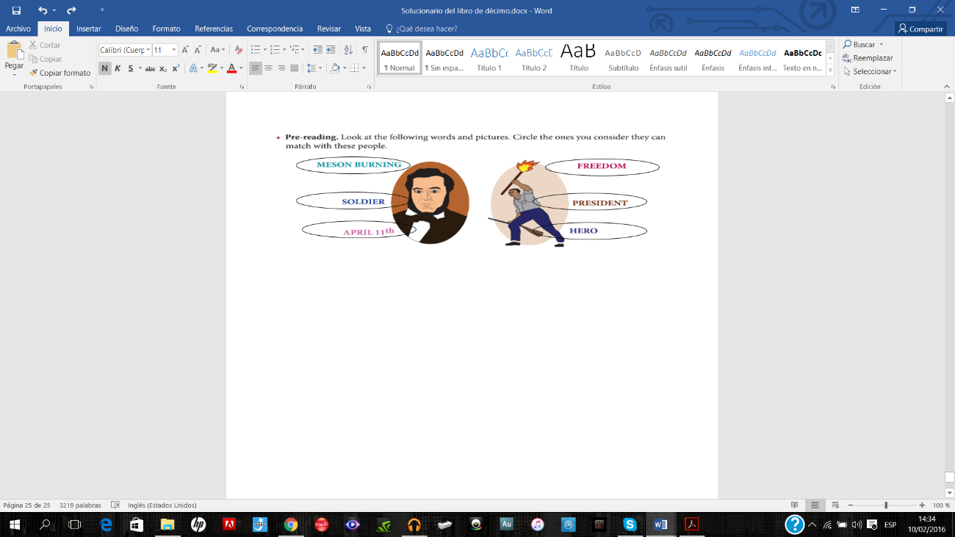

POST- READING. Answer the following questions based on the previous text.

- Who was Juan Santamaría?
R/ He was a drummer and soldier who gave to Costa Rica the triumph by burning the meson de guerra.

- When do Costa Ricans celebrate Juan Santamaría day?
R/ April 11th

- Who wrote the anthem of Juan Santamaría?
R/ Emilio Pacheco

- Who was William Walker?
R/ He was an American physician, lawyer, lawyer, journalist and mercenary.

Practice
A. Write positive sentences in Future will.

- They will help you with the preparations of the festivity. (help)
- She will get you a drink. (get)
- I think my team will win the match on Saint Patrick day. (win)
- Maybe you and I will do a language course in Russia. (do)
- I will buy the tickets for the bullfight in Zapote. (buy)
- Perhaps she will do this for you, that’s for sure. (do)
- Maybe I will stay at home. I am sick (stay)
- She hopes that her mommy will cook dinner tonight. They will celebrate Thanksgiving Day. (cook)
- I’m sure they will understand your problem. (understand)
- They will go to the party. (go)

B. Write negative sentences in Future will.

- I will not cook tonight. (cook)
- People will not understand the importance of that celebration. (understand)
- The parade will not have comparsas. (have)
- Children will not participate in Halloween activities. (participate)
- I will not have breakfast for tomorrow. (have)
- Maybe he will not prepare the activity for Independence Day because she will be busy with the independence parade next Saturday. (prepare)
- Perhaps they will not fly to London to celebrate St George’s day with their families. (fly)
- Mom and dad will not stay at home; they will fly to USA for the St Patrick activities. (stay)
- You and I will not attend the party (attend)
- They will not bring the mascaraed for the celebration. (bring)

C. Write questions in Future will. Organize the following words.

- (you / drink / soda pop)
Will you drink soda pop?
- (Jenny / become/ the host)
Will Jenny become the host?
- (it / rain / tomorrow)
Will it rain tomorrow?
- (the teacher / organize / the civic ceremony)
Will the teacher organize the civic ceremony?
- (what / they / celebrate)
What will they celebrate?
- (when / she / be / back)
When will she be back?
- (who / buy / the food / for the activity)
Who will buy the food for the activity?
- (where / we / meet)
Where will we meet?
- (what / you / sing)
What will you sing?
- (what / he / do / tomorrow)
What will he do tomorrow?

D. Place the following adverbs in the sentences. Do not repeat them.

Next week
Next month
Next year
The day after tomorrow
Next Tuesday
Tomorrow
Tonight

- They will have lunch at the auditorium tonight.
- I will walk to Cartago to the Basilica of Los Angeles next week.
- She and I will prepare the Independence Day activities next month.
- You will exchange gifts on Christmas Eve next year.
- People will sell flowers on St George’s day the day after tomorrow.
- The teacher will buy the decoration for the Annexation of Guanacaste ceremony next Tuesday.
- He will have a dinner with the guests tomorrow.

E. Place the following adverbs of certainty in the sentences. Do not repeat them.

Definitely
Surely
Probably

- Mariah will definitely sing the anthem of USA.

- They will surely recreate the scene of the Battle of Rivas.

- The principal will probably attend the ceremony of the Battle of Rivas.

SOME FEDERAL USA HOLIDAYS

- Soldiers who participated in World War II are honored on November 11th.
- Americans prepare special meals to celebrate Thanksgiving day.
- Americans tend to decorate their homes with many lights on Christmas day.
- The people who died in wars in which the US participated are remembered on November 11.
- In the fall 1621 the pilgrims celebrated the first Thanksgiving day.
- Veterans day is celebrated with parades.

MOTHER’S DAY HISTORY
- The first mother’s day was celebrated in ancient Greece.
- In Rome, mother’s day is celebrated in honor of Cybele.
- Most Central American countries celebrate mother’s day in May.
- In France, mother’s day is celebrated with a family reunion.
- In Spain, mother’s day is celebrated I honor of the Virgin Mary.
- Costa Ricans celebrate mother’s day on August 15th.
MATCH
- Christmas . . . December 25th
- Labor day . . . May 1st
- New Yer . . . Janurary 1st
- Mother’s day . . . Augutst 15th
- Day of cultures . . . October 12th
- Independence day . . . September 15th
- Annexation of Guanacaste . . . July 25th
- Battle of Rivas . . . April 11th

AMERICAN HOLIDAYS

- Which tradition is practiced on Easter?
Color eggs and give to the children

- What do people celebrate on Easter?
The resurrection of Jesus Christ

- What do people give in Valentine’s day?
Candies and flowers

- When were the first Valentine’s day cards sold?
In the 1840s
- When is Father’s day celebrated?
Every third Sunday of June.

- Who proclaimed Father’s day?
President Lyndon

- Where was the first Father’s day held?
In Spokane, Washington

- Which of the three holidays is a religious celebration?
Easter

HALLOWEEN: TRADITONS AND CUSTOMS

COSTUMES | CHILDREN OBTAIN
GHOSTS | Candy
SKELETONS | Cookies
STORYBOOK CHARACTERS | Fruit
TV Characters | Money

COSTA RICANS CELEBRATE THE INDEPENDENCE DAY ON SEPTEMBER 15

- On September 14th, the freedom tourch arrives to Costa Rica.
- Independence day celebration includes parades.
- The text talks about the Independence day celebration in Costa Rica.
- The lantern parade is held on September 14th.
- In our country, students carry the freedom torch of independence.

